|  |  |  |
| --- | --- | --- |
| SAMPA News December 2021 | | |
| With South Africa now firmly in the grip of the Covid 4th wave and the uncertainty around the impact of the Omicron variant things can hardly get more challenging for our industry. Gauteng is clearly the epicenter of 4th wave of infections and it is unclear just how much immunity vaccinations offer gginst Omicron. It is however clear that vaccinations remain the most proven protection against severe Covid illness and possible hospitalization. Persistently high raw material prices and a weak rand have made it very tough last quarter in 2021. 2022 looks to be just as challenging as many South Africans continue to resist getting vaccinated.  Global shipping and commodity prices seem unlikely to give up the gains made in 2021 and fuel prices are at historic highs.  Eskom’s fragile grid and continued blackouts hamper growth in the economy and with little likelihood of an improvement in Eskom’s performance next year South Africans are forced to use expensive energy alternatives. |  |  |
| Vaccinations remain the most proven protection against severe Covid illness and possible hospitalization. | | |

|  |  |  |  |
| --- | --- | --- | --- |
|  |  | |  |
| When is a Levy Fair? **Is a levy just another form of TAX or can it be a fair cost recovery mechanism?**  In October 2019 the NRCS proposed a two tier levy for the Processed Meat Industry. SAMPA strongly opposed it and as a result it was not implemented. So what now? | |  | |
| It’s important to be aware that the NRCS Levy has not gone away. It’s just been on hold for the past 2 years.  In October 2019 the NRCS proposed a two tier levy that would fund the implementation of VC9100.  SAMPA opposed this levy on behalf of its members, as the NRCS budget was unacceptably high and lacking details and the methodology was punitive to large volume producers. SAMPA proposed an alternative levy collection model which the NRCS took forward to their parent Ministry the DTIC.  In November 2021 the DTIC approached SAMPA and both parties met to share our thoughts and ideas on a way forward. Information was shared and the DTIC committed to hold further discussions with SAMPA after consulting Minister Patel.  So what options are on the table?   1. **Levy per kg** based on two tiers – High Volume /Low Value and Low Volume/High Value 2. **User pay model** similar to what is used by Food Safety Agency for the implementation of R1283. 3. **Levy per Kg capped** at maximum R’s value per vendor   **What does the NRCS Act: 2008 say?**  Section 14 (3) (b) “ Any person who imports, sells or supplies a commodity, product or service to which a compulsory specification applies, must pay such fees to the National Regulator as may be prescribed by the Minister after consultation with the Minister of Finance”  The NRCS Act is thus silent on the mechanism of determining the levy and it thus rests with the Ministers of DTIC and Finance to determine appropriateness of the levy fee structure.  It goes without saying that a user pays principle is the fairest form of cost recovery.  Flat levies based only on volume are a form of TAX as they ignore actual costs incurred by the Regulator and focus more on revenue generation.  SAMPA will continue to work to find the best solutions for members but it is important for all members to note that this matter is back on the negotiating table for possible implementation during 2022.    A  **ationn tly o relocate fice from 1st al and is only seen by meat a f cost recovery and msot ement in** |  | |  |

**SAMPA asks members for information**

For many years SAMPA has tried to obtain information from

Member organizations, in order to develop a dataset which could be

used when promoting the importance of SAMPA as an industry

representative body to Government regulators.

This year for the first time we were able to obtain data from 29

of SAMPA’s 46 members. Here is what we found.

The above makes interesting reading and unsurprisingly emulsion products (Polony, Russians and Vienna’s) make up 71% of total volumes. The “Other” category comprises of Crumbed, Reformed, Ribs and Burgers.

This now provides SAMPA with accurate information which we

can use when in discussion with for e.g. DTIC & NRCS.

I am certain all our members will find this information interesting.

If you have not yet submitted your companies information,

please send it to [peter@sampa.org.za](mailto:peter@sampa.org.za)

***All information is treated with the strictest confidence and***

***will never be shared or made available to anybody.***

**SAMPA offices relocate to Cape Town**

I have decided to relocate back to Cape Town in February 2022 after more than

4 years in Johannesburg. SAMPA offices in Randburg will close on 31st January 2022.

To reduce costs to SAMPA I will work from a home office in Cape Town, email and cell numbers remain the same.

[peter@sampa.org.za](mailto:peter@sampa.org.za) and 083 2553486

|  |
| --- |
|  |
| South African Meat Processors Association NPC Peter Gordon  The Workspace, 63 Bram Fisher Drive  Robindale  2194 |
|  |

**Marketplace**

**Freezer Room -** 70 pallet freezer room including compressors and blowers, only used for 6 months. Currently disassembled and in storage in Cape Town – contact **Guy 082 440 4844**

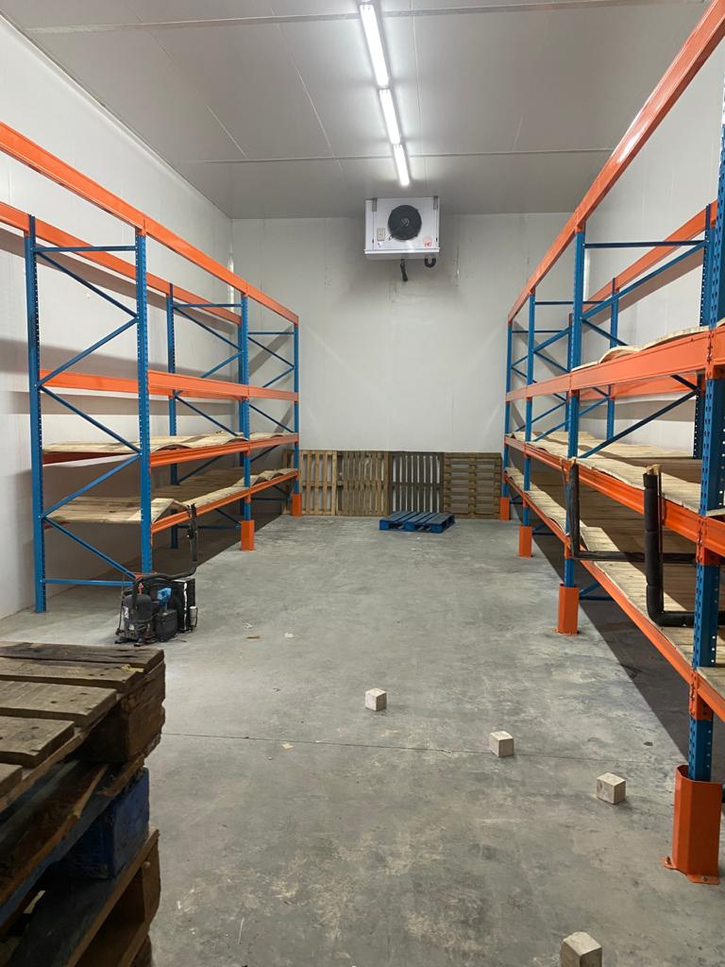

**Meat Processing Equipment**

Cold Rooms - various sizes Alpina 300L bowl Cutter

Pickling Pumps KS Emulsifier

Generator Treif Slicer

Scales Treif Dicer

Pallet Jacks Apollo Casing Peeler

Maurer Smoker – Large with smoke generator Poly Clip Casing Clipper

And much more

Please contact **Paddy on 061 636 1681** all products available to

view in Johannesburg.