Sampa News
  - October 2021
SAMPA in the Press
During July South Africa was wracked by violence in Kzn and Gauteng resulting in significant disruption to supply chains and especially the supply of MDM. SAMPA took to the media in a campaign to highlight the impact of supply chain distruption and to appeal to DALRRD to provide dispensation which would allow faster clearing of inbound shipments of raw material.

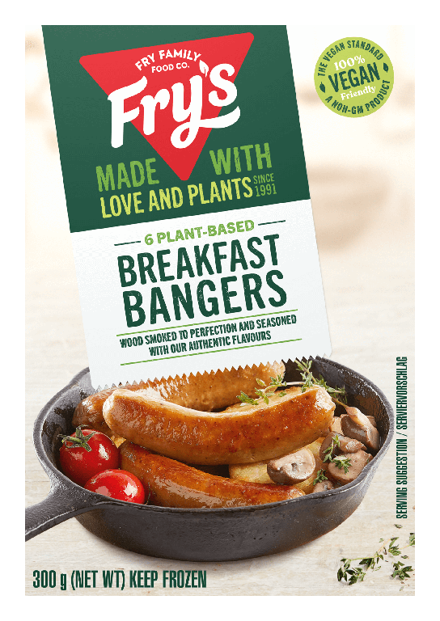
Meat Analogues – Friend or Foe?

July press campaign
SAMPA and AMIE combined forces in late July to launch a media campaign to highlight the supply chain challenges and impacts on business following the looting of cold storage facilities in Durban earlier that month.
Media interest was unprecedented and between 29th July and 3rd August Paul Mathew (AMIE) and I, had been on TV, Radio and in most print media across South Africa.
DALRRD reacted and issued dispensation on Friday 30th July providing relief for importers. This together with Transnet Port Authority assistance enabled the rapid clearing of backlogs in Durban Port by mid-August.
In total 5 cold storage facilities in Durban were damaged during the unrest. By the time of writing two of these have been repaired while others are being repaired or rebuilt
Red Meat Levies to Increase from 1st November 2021
The red meat levy administrators have sent out letters to all registered businesses that the various red meat levies will increase on 1st November 2021.
The red meat levy for Processors will increase to 2, 40 cents per kg
Please direct any queries to Tina Carr 012 348 7572 accounts@levyadmin.co.za.
If you are not registered please contact Tina or visit the RMLA website for more information. www.levyadmin.co.za
Meat Analogues- What do they mean for our industry?
What started out as a niche food category to satisfy a meat free diet or just healthy eating choices is fast becoming a trend and could become mainstream in future. Beyond Beef was perhaps the first manufacturer to see the benefits of riding on the back of red meat by creating a burger that oozed red juice, even though it contained no meat. The meat free industry has realized that what consumers want is the delicious umami flavours of meat but without the meat!
This trend started in 2016 in the USA and has now become a global food trend of juggernaut proportions. In South Africa, meat free ranges appear on retail shelves almost weekly. Is this a trend, is it food fashion or will this become a mainstream offering that will pose a threat to the meat industry?
I first raised my concerns in 2020 and then approached DALRRD and the DOH as many of these meat free products were contravening labelling laws as well as misleading customers by using meat names such as “ Meat Free Meat Balls, Meat Free Boerewors, Vegetarian Bratwurst, Beef style Mushroom Mince “and many others. When last did you look at these ranges in your local supermarket?
What do you think about this trend? Have you seen your shelf space reduced to make way for Mushroom burgers or Vegan Nuggets?
The meat industry has been largely silent or naïve to this mega trend and now is the time for us to act or stay silent forever.
Drop me a mail or call me to share your thoughts - peter@sampa.org.za or 011 086 0650
SAMPA needs your support to compile industry information
SAMPA is often asked to provide information to Government on the size of the sector, number of staff employed, raw material used and other information that can provide evidence of the importance of the sector to the economy.
It is very embarrassing to have to say that SAMPA has no information about our industry or our members.
By your company providing SAMPA with a basic data set, it will enable SAMPA to compile industry information that will allow us to have a sense of the size of our industry and our membership. Company specific information will treated confidentially and always used in a way that protects individual company data.
By SAMPA having data, it will greatly assist us when dealing with Government departments.
It would be greatly appreciated if you could please complete and return the attached questionnaire.
Opening of EU countries for exports of Poultry to South Africa
SAMPA has written to the DG at DALRRD Mr Ramasodi asking for those countries declared AI free by the OIE to be re-opened to South Africa. We have given DALRRD 14 days to respond.
Currently those countries are Ireland, Netherlands and France.
There appears to be great resistance by the DALRRD vets to engage in bi lateral negotiations required to re-open these countries to imports. It is important that SA has other sources of MDM besides Brazil.

Regards
Peter

Vaccinations save lives, yours, mine and all of those around us. Vaccinate today.
